  

**CLOUD APPLICATION DEVELOPMENT (GROUP 1)**

**PHASE I: ASSIGNMENT NOTEBOOK SUBMISSION**

**NAME :AGNUS.P**

**EMAIL: [agnusagnus15@gmail.com](mailto:agnusagnus15@gmail.com)**

**Git repository URL:** **[https://github.com/au110621104004/Agnus.git](https://github.com/au110621104021/Sneha.git)**

**TITTLE OF THE PROJECT :**

**PROJECT 4**

**IMAGE RECOGITION WITH IBM CLOUD VISUAL RECOGNITION**

**ABSTRACT:**

Bird images are injected in a convolutional neural network (CNN) to localize prominent features. First, we create an image generator for the training data. Then, we load training images. After that, we create a neural network and the convolutional layer. Finally, we load the unknown bird image and applied the argmax function to get a probability of bird features.

**INTRODUCTION:**

To categorize birds according to their natural habitats, diet and family, our study developed a convolutional neural network (CNN) model [10] to extract landmarks from captured or downloaded bird images. Previously, by identifying local characteristics. First, we locate the raw input data of myriads of semantic parts of a bird. Second, depending on the shape, size and color of the birds, the feature vectors of each generic part are detected and filtered. Third, a CNN model is trained with the images of birds during a graphics processing unit (GPU) [1] in order to extract the feature vector [5]

**Phase 1: Problem Definition and Design Thinking**

**Problem Definition:** The project involves creating an image recognition system using IBM Cloud Visual Recognition. The goal is to develop a platform where users can upload images, and the system accurately classifies and describes the image contents. This will enable users to craft engaging visual stories with the help of AI-generated captions, enhancing their connection with the audience through captivating visuals and compelling narratives.

**Design Thinking:**

**1 .Image Recognition Setup:** The ability of software to identify objects, places, people, writing and actions in digital images.

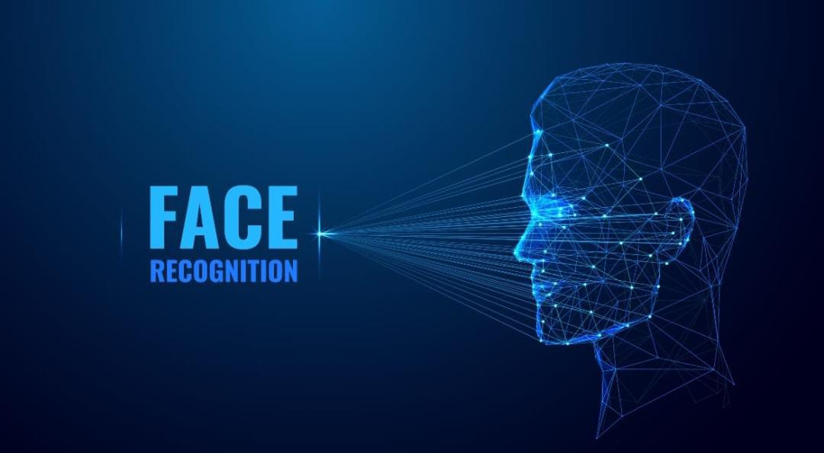

**2. User Interface:** Design a user-friendly interface for users to upload images and view the AI-generated captions.



**3. Image Classification:** The task of assigning a label to an image from a predefined set of categories.

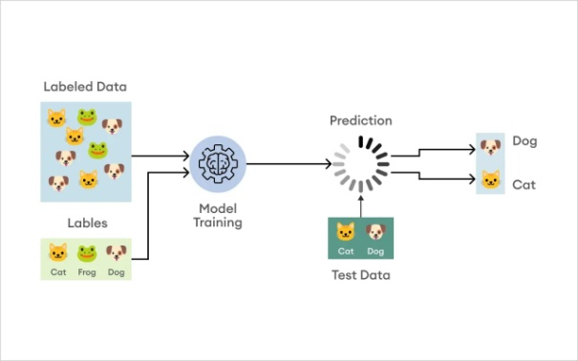

**4. AI-Generated Captions:** Integrate natural language generation to create captions for the recognized images.

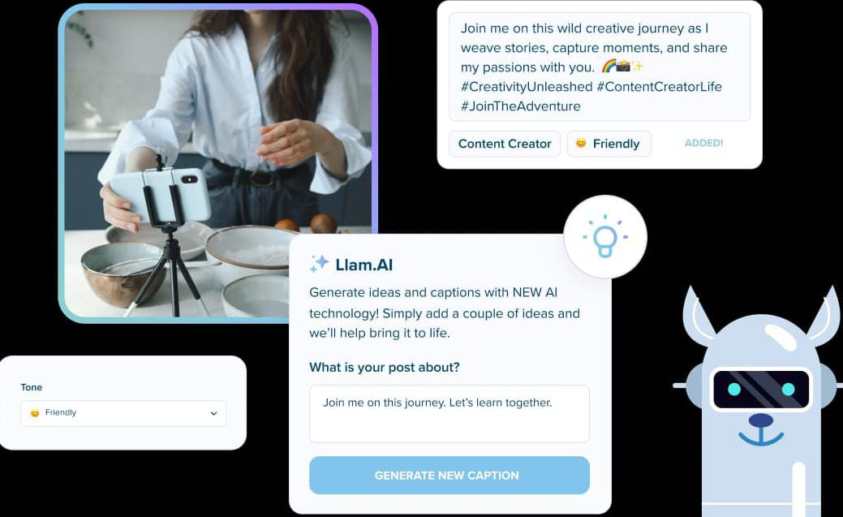

**5. User Engagement:** The amount of time someone spends with your web page in focus or app screen in the foreground.



**HARDWARE REQUIREMENTS :**

* Pentium IV or higher, (PIV-300GHz recommended)
* 256 MB RAM
* 1 GB Hard Free Drive Space

**SOFTWARE REQUIREMENTS :**

* IBM cloud
* Mobile application
* Convolutional Neural Network (CNN)
* Matterport,Hive Moderation,Congnex VisionPro
* National Instruments Vision Builder
* Android Studio project using an API key

**CONCLUSION:**

Image recognition technology has transformed the way we process and analyze digital images making it possible to identify objects, diagnose diseases, and automate workflows accurately and efficiently.